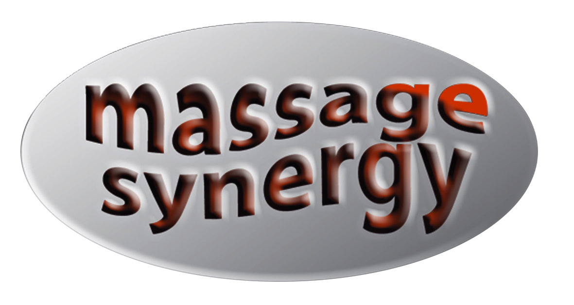

INJURY ADVICE

Musculoskeletal Injuries/soft tissue inflammation

How long will it take to recover?
Healing time depends mainly on blood supply. The blood brings the elements necessary for healing.

Nutrients – think of injury as a remodelling job. Nutrients are the building materials for healing.

Oxygen – This is the energy source for the project. You cannot have fire without oxygen. The body cannot heal without oxygen.

Inflammatory cells – These are the workers. They carry away the old blood and dead tissue. They fight off infection. They assemble the building blocks. Unfortunately the best they can do is a slick patch job.
Most body tissue, except the liver, heals with scar tissue. The larger the injury, the larger amount of scar tissue. It is a biological fact that explains why the body never totally forgets an injury.

Blood supply to certain parts is inherently better that to other parts. That is why injuries heal at different rates. Skins injuries to the face heal within a few days because the blood supply to the face is one of the best in the body.

Treatment of Muscular Injuries –

An injury, whether in sport or elsewhere, will almost always result in bleeding. This may be obvious as in a cut or hidden in a sprained ankle, corked thigh or any other torn or tissue damage.
Irrespective of the cause of injury, the treatment is the same. The treatment can be divided into two parts.

- The first aid type treatment:

The acute stage: - immediately – 48 hours – apply RICE treatment, Rest, Ice, Compression, Elevation – rest, ice 10 min on 10 off, compression & elevation. General massage can be applied elsewhere away from the injury site to reduce swelling and prevent secondary problems from developing.

Aims of treatment: to prevent further tissue damage, ease pain, prevent loss of ROM, to regain full power & function.

2. Heal, Stretch and Strengthen.

Sub/Post – Acute 72 hours – 6 weeks – when there are no more signs of inflammation & reduced swelling, this is the healing stage. Gently massage can begin to prevent adhesions forming from scar tissue and any muscular imbalances occurring.

Chronic: 6 weeks – 6 months – long term – low term inflammation has continued for a considerable time, or large trauma in the past has not been given appropriate treatment. This needs to be treated with much deeper friction in order to break it down, and deep long pressure to help re-align the fibres.

During Rehabilitation: - Deep massage will break down excessive scar tissue from injury, deep massage to all muscles associated with the injury site to find the root of the cause or contributing factors may be found.

Periosteum (periostitis) Dislocations, Sprains, Fractures – See a doctor first, then massage is recommended.

