West Golf Club, Bacchus Marsh
PH: 03 5367 3492
E-mail: westgolfclub@live.com.au
P.O. Box 109
Bacchus Marsh-Balliang Rd,
Bacchus Marsh.

January 2009
Volume 2, Issue 1
Inside this Issue
1 | Important information.  Bar Roster.  This Months Events
 | Wednesday Competition
2 | Kitchen news  Fading Greens  Ballarat Pennant
Working Bees
Advertising
Junior Golf

Fundraising
Coming up next Month
3 | E-newsletter  Adult Beginners Clinic  Sponsors
 | Photo Corner
4 | Photo Corner (Cont’d)
West Golf Club News

Welcome to your monthly newsletter
Editor Dotty Hazell
For any contributions please e-mail me at dotty.hazell@hotmail.com or
Phone 0438 692 392

Important information
Visitor Sign in Book
We have a visitor sign in book near the front door of the club room. It is now an insurance requirement that all non-members must sign the book. Green fee players are exempt as their fee constitutes them as members for that day.

Bar - Licensed Hours
The Bar is licensed from 11am -10pm Monday to Saturday and from 12-6pm on Sundays. The bar is closed on Good Friday. No one will be served Alcohol outside of these hours.
RSA laws are constantly getting tighter and spot checks are becoming more frequent.
By order of the Nominee –
Garry Sharples.

Bar Roster
The Bar roster is up and running.
Below are the dates and names. If anyone can’t do their rostered day due to a prior commitment have a look to see if you can swap with someone else. A list will also be posted on the notice board. If you don’t have keys see someone on the committee on the Saturday before and keys will be organised.
The hours are Sundays from
12-4pm. Duty includes – bar, green fees & club hire.

04-01-09 Roger Longmuir
11-01-09 C. Chapman
18-01-09 Jim Wilson
25-01-09 Sharon & Bruce Fordyce
01-02-09 Dawn & Eugene Fogolyn
08-02-09 Kylie Fisher
15-02-09 Michele MacDonald
22-02-09 Leo Shea
01-03-09 Dotty Hazell
08-03-09 Lynette Edwards
15-03-09 Jim Wilson
22-03-09 Sharon & Bruce Fordyce
29-03-09 Dawn & Eugene Fogolyn
Wednesday Competition
This is a member’s comp for the men, held every Wednesday. Tee off time is 8:00am but must be no later than 10:00am, players hitting off after 8:00am must arrange their own group. After the 18 hole round players can enjoy light refreshments in the clubroom with the usual banter that goes with the game of golf. On the first Wednesday of the month there is a BBQ (which is always well attended). New players are always welcome. You will be assured a good time and it’s a great opportunity to meet other members. For those members who work, why not come along when you are on holidays. Keep an eye out on this space as the weekly winners and their scores will be submitted to this newsletter along with anything that might have happened or is of relevance. If you have anything to put in please contact Dotty Hazell or Roger Longmuir.
This Month’s Events
Sunday 4th January
Working Bee – 14th Green

Saturday 10th January
2:00pm
Committee meeting

Tuesdays
9:00am
Ladies Mid-Week Comp
Cost: $4.00
Come along on your day off or holidays

Wednesdays
8:00am
Men’s mid-week comp
Cost: $3.00
Come along on your day off or holidays

Kitchen News
The kitchen past its annual inspection with flying colours.
The ladies have got together a catering package to people wanting a place to hold a wake, offering light refreshments at a cost of $7.50 per head. If you or anyone you know needs to organise a wake you/they can phone Noella Dickson on 5367 2918 or Michele MacDonald on 5367 3601
Fading Greens
You might have noticed lately that the greens seem to be yellowing a bit. Unfortunately this is to do with a disease on them. This disease is something we have never had before, and has been sprayed at a cost of $600 to the club. Before long your greens will be green again.
Ballarat Pennant – Group 5
The Ballarat District Pennant for 2009 starts in March next year. If you are interested in playing please see Mike Hazell to put your name down. There will also be a list put up on the board. The Pennant goes for around 6 weeks. We need at least 5 men, with a handicap no higher than 27.
Working Bees
The January Working bee had a huge turn out considering it was barely the start of 2009. We got lots of work done on the 14th green along with putting more sand on most of the existing greens. A huge thank you goes out to everyone who came along whether it was for 1 hour or for 8 hours everyone worked well together to get everything done on such a hot day. The main work still to be done on the 14th now is laying of the watering pipes and the turf needs to go down.
Coming up next
Month

Friday 6th February
4.30-6:00pm
6 hole comp tee off
Cost: $6 includes BBQ dinner
$4 adults not playing
First night for 2009

Friday 6th February
6:00-7:00pm
Junior Clinic
Cost: $5.00 includes BBQ dinner
$2.00 children not playing
First night for 2009

Saturday 14th February
2:00pm
Committee meeting
Everyone welcome

A Big Thank you needs to go to Noel Hine from Hine Bros Clay pits for delivering the sand required to build up the new 14th green.
Working Bees still planned for the new 14th green and the tree planting grants. A job list will be up on the notice board closer to the next working bee for you to put your names on.
The dates are:
Sunday 22nd March 2009
Sunday 17th May 2009
Sunday 31st May 2009
Sunday 14th June 2009
Sunday 28th June 2009

Advertising
We are placing an add in the 2009/10 pocket book to better advertise our golf club locally. We have a lot to offer, so if you know of anyone starting out in golf or looking for a venue to hold their next function direct them to the next edition of the pocket book or our true local web advert.
Anyone can sign up and add a review to the listing so please log on to www.truelocal.com.au and register and tell the public how great our Club is. When you’ve registered all you have to do is search “West Golf Club” in “Bacchus Marsh” and both listings should come up. When they do pick one and click on “review” just fill in what ever it asks and in a day or two your review will be on line for all to see.
Junior Golf
After a long break over the Christmas period, the junior clinic/comp will be resuming next month (February). We hope you all had a safe and happy break.
Mike Hazell has been working with the VGA to secure a $700 grant to hire a local golf professional to spend 10 weeks helping coach the juniors. Hopefully this will give the juniors a different perspective and Mike and Lawry might pick up a couple extra tips to work with as well. Hopefully this will take us to the end of the summer season.
The junior golf e-mail address is juniorgolf@live.com.au
Fundraising
2009 Golf Calendars
Leo Shea is printing up another calendar for 2009. These are similar to the one he did last year. They should be available by now, so please see Leo to order your copy. The cost is $10 this year. Last year was the first time the calendars were made and the price didn’t quite cover costs, therefore the price has had to rise.
E-Newsletter
For those of you who want your newsletter e-mailed to you (this will help reduce the cost of printing) please e-mail the golf club on westgolfclub@live.com.au
I will also be posting it on the true local web add which will be available for download. If anyone does not want their photo on the web let me know so I can not use their pictures.

Adult Beginners Golf Clinic

The first clinic had a small group of 4. It was a pretty hot day. But the 2
hour clinic turned into 3-4 hours, with everyone wanting to learn more. Lots of water was drunk to keep the hydration up and parts of the clinic were even held in the clubhouse.
If anyone else would like to take part in another clinic, phone or See Mike Hazell on 0425 818 446 or 0438 692 392

Please visit and thank our sponsors
Foodworks – Bacchus Marsh. Donating all of the sausages for our Friday night golf, and at our working bees
I need to get more gift vouchers donated for the 2009 season of the Friday night golf so if anyone knows any business’s that might
like to help, please don’t hesitate to ask them or pass the information on to me so I can chase it up. I have a
letter I can give you to give to the businesses.

Photo Corner
This space is for any photos you would like to submit. Whether it is something you snapped on your mobile or an event you’d like to
share. Even holiday snaps of your trips.

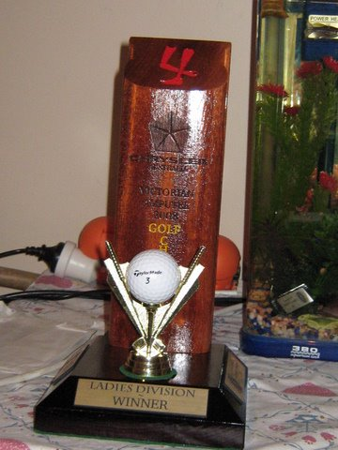
Denise O’Meara one of our newer lady members won this trophy at the amputee’s tournament. Well Done Denise. Denise has had a run of bad luck lately so let’s hope she gets back into form soon so she can bring home more trophies like this one.

14th Green working bee
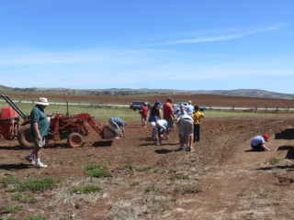

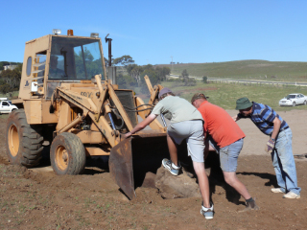

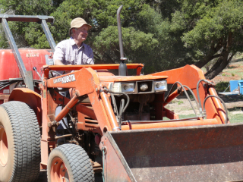
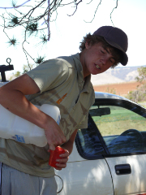

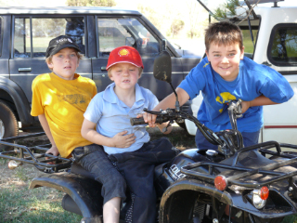

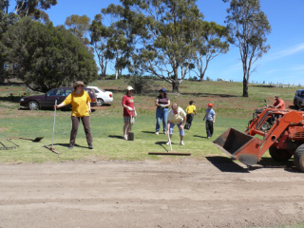

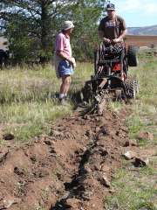

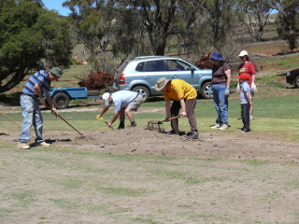

Adult Beginners Clinic



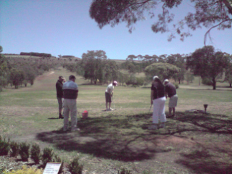
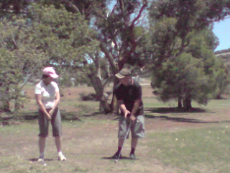

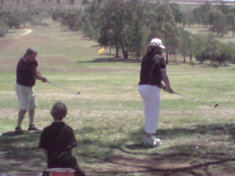
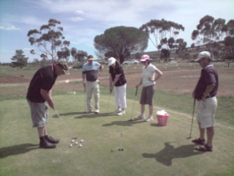

If anyone has any funny stories of things that have happened through
the month or jokes please send me an e-mail or give me a call.

