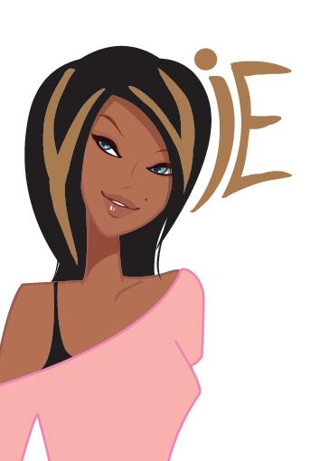

LADIES, Impress your clients & WOW your friends
with a professional hairstyle that looks great in 3 mins!
Turn more heads in less time -
No Blow drying, No Straightening, No Curling
for up to 2 Months GUARANTEED;
just looking terrific and feeling fabulous
Call Yvie now on 0411 394 637

Free hair care product worth $35 with every hair session

Yvie Inc.
0411 394 637
1300 762 624

