“Pawsimonials”
Our Client's have a "Story” to tell you of their experience using
T. Bone's Dog Walking & Pet Care Services.

Toni, I thank you for taking such good care of Teddy (my Maltese X) whilst I was laid up for those few months. Your care and attention to Teddy’s well being was a comfort. It is difficult to trust, that another person could possibly love your own pet as you do yourself. I would like to take this opportunity to let others know that they can rest assured when “Toni” from T. Bone’s Dog Walking & Pet Care is caring for what to most of us is our much loved member of the family and best friend that they are in good hands..
Warm regards - Teddy and Chris Drake: Drummoyne 2011

"Toni from T-bones is the other mother your pets always wished they had. Toni is professional, hard working and most importantly she dotes on your furry friends so there is never a worry if they need a pat, need to be fed, walked or kept company while you are away. I highly recommend Toni and T-Bones for anyone looking for pet care alternatives -the service is faultless and her genuine care for animals second-to-none."
K. Slaughter: Leichhardt 2011

The family was going away for the weekend and unfortunately we could not take Boris, our beloved Beagle. All options for care from friends and extended family had been exhausted and we were getting desperate! I rang Toni and thank God she was available to help. We could not have been happier with Toni's care of Boris. From the moment they were introduced, Boris warmed to Toni, and then after a good half an hour of tug-of-war, Boris clearly considered her as one of "his people" (our pet name for those Boris considers family).
Toni had given Boris the care that any family member would and he clearly did not feel abandoned. The day after we arrived home, Toni provided a detailed email summary of their time and some lovely photos of them together. Given the wonderful service Toni has provided and the level of care and thoughtfulness that she has shown to Boris, we will now be seeking Toni as our preferred carer of Boris, even over our friends and family! And besides, how could we deny Boris another opportunity to spend quality time with one of "his people"!

J. Avery: Leichhardt 2011

“Pawsimonials” Con’t

Toni, I have every confidence in your ability to care meticulously and warmly for Psyche and I have every confidence in Psyche to wrap you around her little paw just where she has me!
Our dog Toby came into our lives just at the right time he helped us get through some difficult years. He also comes to work with me and heals and comforts children who have faced abuse and trauma. So you see Toby isn’t just a dog, he is a vital part of our family and a healing life line for many children. So when we needed someone to look after him we could not hand him over to just anyone. We were in need of a pet sitter and our vet gave us a phone number. I decided to phone. I got on the end of the phone was not just a person I did not know, I got Toni. Within seconds I connected to her and I knew our Toby would not just be well looked after, I knew he would be loved and I can tell you I was not wrong… in fact I was far from wrong. Toni brought to our family the blessing of who she is with the warmth of love for our Toby, her care for us as a family and the professionalism of a business woman. Yes she was a business woman and that is good because she provides great service delivery but trust us when we say she is much, much more. So it was an honour when Toni asked us to write something for her website and so all I can say is, let this woman into your life and into looking after your dog/cats... by the way she also does a great bath-time routine… for your dog, not you!!!

Mary Jo: Concord 2011
The best testimonial is the photo of you and Psyche looking happy and relaxed together. She is a discerning spaniel!
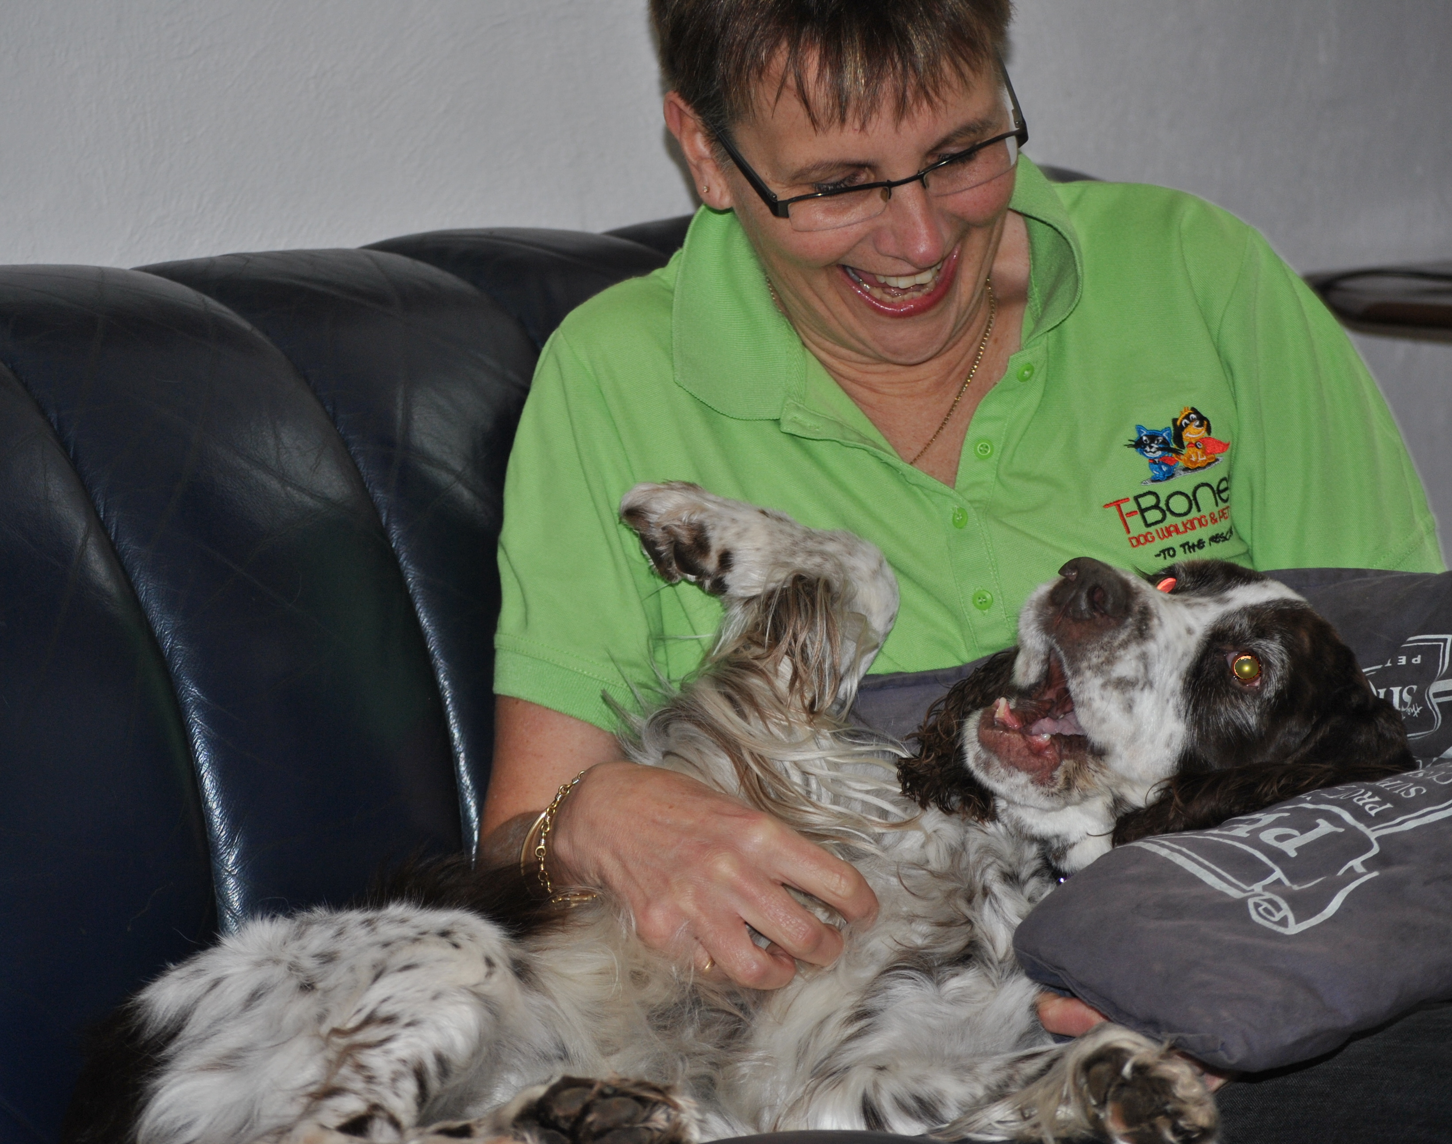
S. Cameron: East Balmain 2011

