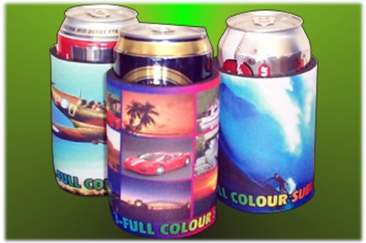
Quantity | Price | VIBRANT COLOURS, GREAT IMPACT, MORE DETAIL!  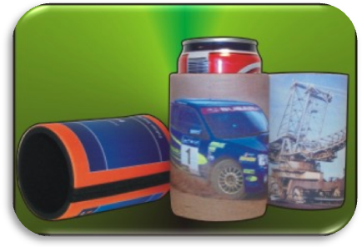  WHY SETTLE FOR A ONE COLOUR SCREEN PRINT? | 
50+ | $4.50
100+ | $4.00
250+ | P.O.A
500+ | P.O.A
1000+ | P.O.A
2500+ | P.O.A
5000+ | P.O.A
DISPLAY YOUR MESSAGE USING  FULL COLOUR  IMAGES FOR MAXIMUM  EFFECT! |  | 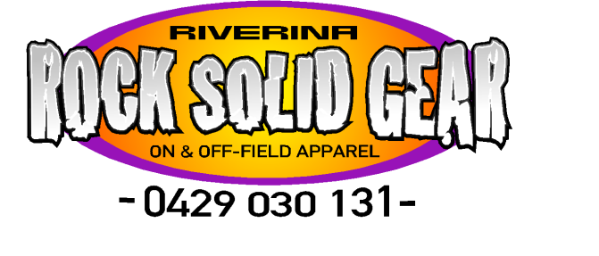  EMAIL : rocksolidgearriverina@bigpond.com
* ALL prices exclude: any artwork charges, freight and GST. Colour correctness CANNOT be guaranteed on full colour printing. Changes in colour WILL occur.
* A Proof Panel is Recommended. No Proof Panel, No Colour Guarantee.

