Trading Hours

Mon- Closed
Tues & Wed- 9am- 5pm
Thurs & Fri- 9am- 8pm

Alternative days also available.
Subject to availability.

Using all natural
Skin Care Products
from the
Dead Sea Cosmetic Range

Gift vouchers
available for that
special someone or special occasion

ABN: 64 686 423 700
Add us on facebook:
Visualize Hhb


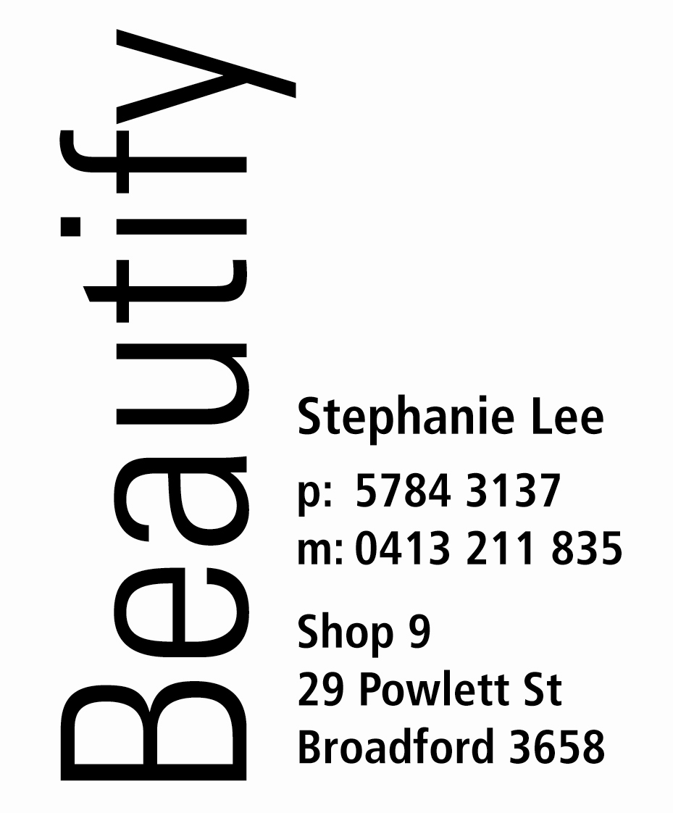


Packages

60 minute Massage
Sugar Glow
1 hour and 45 minutes $65

30 minute Massage
Fresh Facial
Manicure
1 hour and 45 minutes $85

60 minute Massage
Renewing Facial
2 hours $80

60 minute Massage
Men’s Renewing Facial
2 hours $80

60 minute Massage, Renewing Facial, Sugar Glow, Manicure and Pedicure
4 ½ hours $185

Treatments

Body Treatments
Spray Tanning
Full Body $30 Half Body $15
Tailored to your skin type, achieve a deep glowing tan without the harmful rays of the sun. Spray Tanning parties available.

Sugar Glow 45 minutes $35
A full body exfoliation infused in a base of pure almond oil and aromatherapy oils to nourish and soften the skin

Back Facial $70
A relaxing facial for your back! Includes cleanse, tone, exfoliation, steam, mask, massage and moisture treatment.

Massage
30 minutes $30
60 minutes $50

Indulge in our relaxation massage aimed at easing tension with our unique blend of aromatherapy oils. Excellent for reducing stress and soothing the soul.
Facials
Fresh Facial 30 minutes $35
A natural mini-facial including cleanse,tone, exfoliation, deep cleanse, mask and moisture treatment.

Renewing Facial 1 hour $50
Provides deep cleansing, toning, exfoliation, facial steam treatment, mask, moisture treatment and aromatherapy facial massage.
Hands and Feet
Manicure 45 minutes $30
Shaping, buffing, cuticle work, softening aroma soak, hand massage and polish

Pedicure 45 minutes $40
Aroma foot soak, scrub, shaping, buffing, cuticle work, moisture treatment and polish

Nail File, Shape & polish $15 French Polish (with mani or pedi) $5ext.

Acrylic Nails
Full Set $45
Refills $20
Rebalance $30
Nail Art $5 for 2
Soak-off- Full Set $25
- Per Nail $5
Acrylic on Toes $35
Waxing
For Women
Eyebrows $10 Lip,chin,sides $7ec
Full Face $30 Underarm $15
Bikini $18 Half Leg $20
¾ Leg $25 Full Leg $30
½ Leg & Bikini $30 ¾ Leg & Bikini $35
Full Leg & Bikini$40 ½ Arm $10
Full Arm $20
For Men
½ Back or Chest $20 Full Back or Chest$30
½ Back & Chest $30 Full Back & Chest$50
½ Leg $30 Full Leg $40
½ Arms $25 Full Arms $35
Tinting
Eyelash Tint $15
Eyebrow Tint $10
Eyebrow & Eyelash tint $20

