Menu for lesson #1
All the recipes are tasted for lunch on the day

Nibbles: Cheese & Pecan snaps or Parmesan chips.. These will be part of the tasting for lunch
You can also severed with olives or
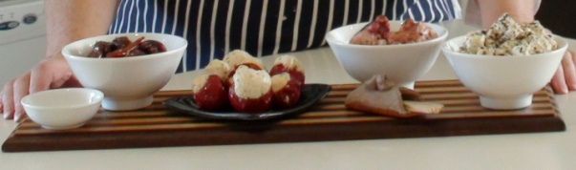 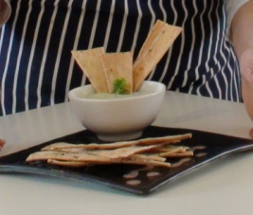 Tapenades of your choice.

Entre: Prawn and Corn Bisque. 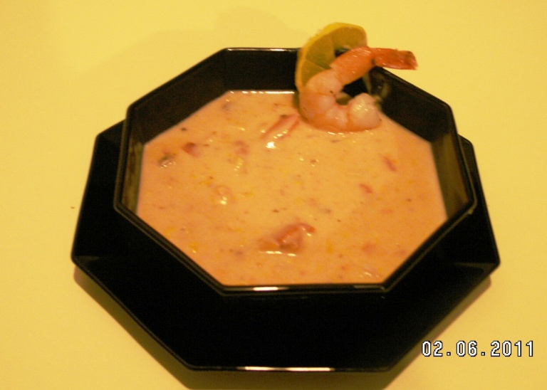 One of the recipes cooked on the day
Main 1: Pork Fillet with rich Barbecue sauce. 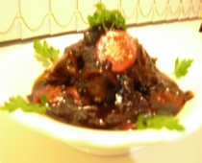 One of the recipes cooked on the day

Vegies or Salad: Roasted root vegies & sautéed greens . 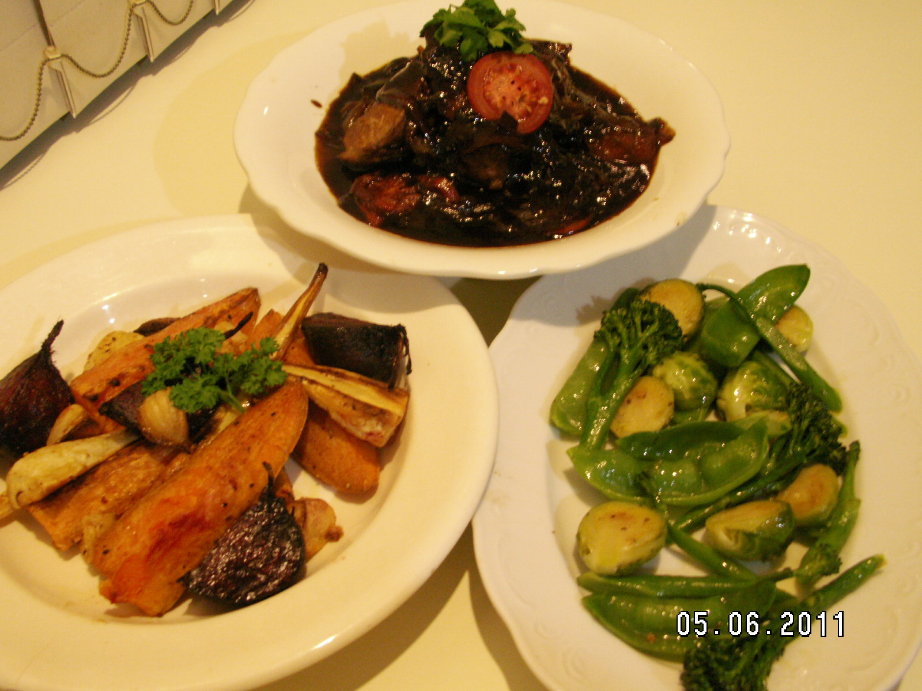 One of the recipes cooked on the day

Cheese: Optional
Sweets: Shortbread & Lemon or Lime Delicious. 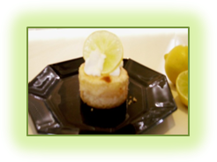 One of the recipes cooked on the day
Please note: some of the above may change slightly according to availability of produce.

