BEAUTY - NEWSPAPER AD
150h X 100w
15 X 3 Column

WARNING:
For optimum results, please make sure that when you PDF your documents, your PDF printer is set to “Press Quality”. If you send your templates to your printer in MS Word format (not encouraged, as printers don’t see Microsoft Word as the standard, but we made it in Word so you can edit it!), make sure to include a note reminding your printer to PDF the document at press quality. All our images are high resolution for print (300 dpi).

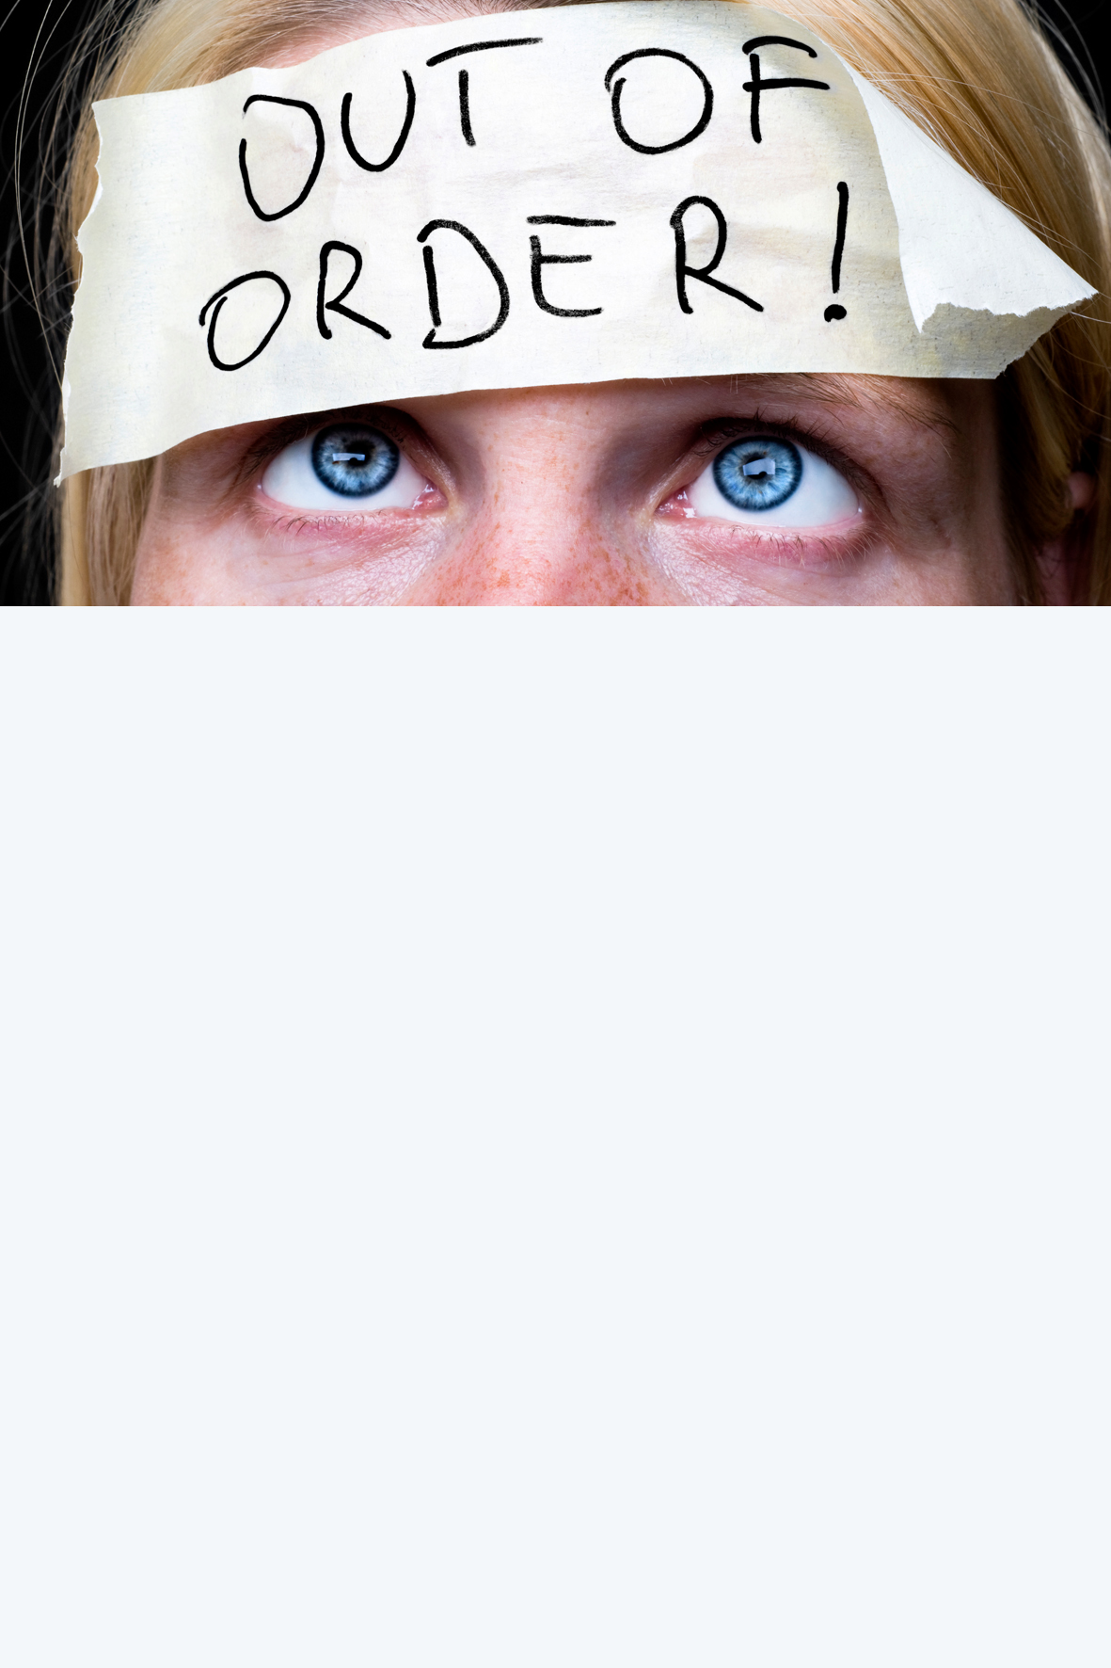

Feeling Frazzled? Treat yourself to our EXCLUSIVE $99 Mother’s Day pamper package!

Hurry!
Only 37
packages available.
Call (salon number) NOW!

Don’t rely on your hubby or kids to buy you a gift you
absolutely adore this Mother’s Day! Book this package
right now for the ultimate de-stress. You’ll get:
- Deluxe Facial worth $85
- Spa Pedicure worth $70
- Mini Manicure worth $43
- Delicious cup of herbal tea or filter coffee worth $4
- 1 and ½ hours of relaxation – PRICELESS!
Total value $202, you pay only $99!
Our Cast-Iron Guarantee: In the unlikely event that you're not COMPLETELY delighted with everything about your experience with us, we WANT you to say so right away, and we'll either re-do it for free, or give you a prompt and full refund - it's your choice
I just LOVE coming to (salon name)! It’s so easy to just forget about the world and relax. – Becky, Account Coordinator and mother of 3

CALL NOW 00000000
Salon name, salon address
Salon name/logo, address, suburb

