Cakewalk – Girls 3 piece summer set:
Pants: Stunning Coral Cotton Stripe Waist Pants RRP $155.00 $75.00
Top: Stunning Floral Silk Shirt RRP $130.00 $62.00
Jacket: Pink Cotton/Resin Sleeveless Jacket RRP $150.00 $72.00

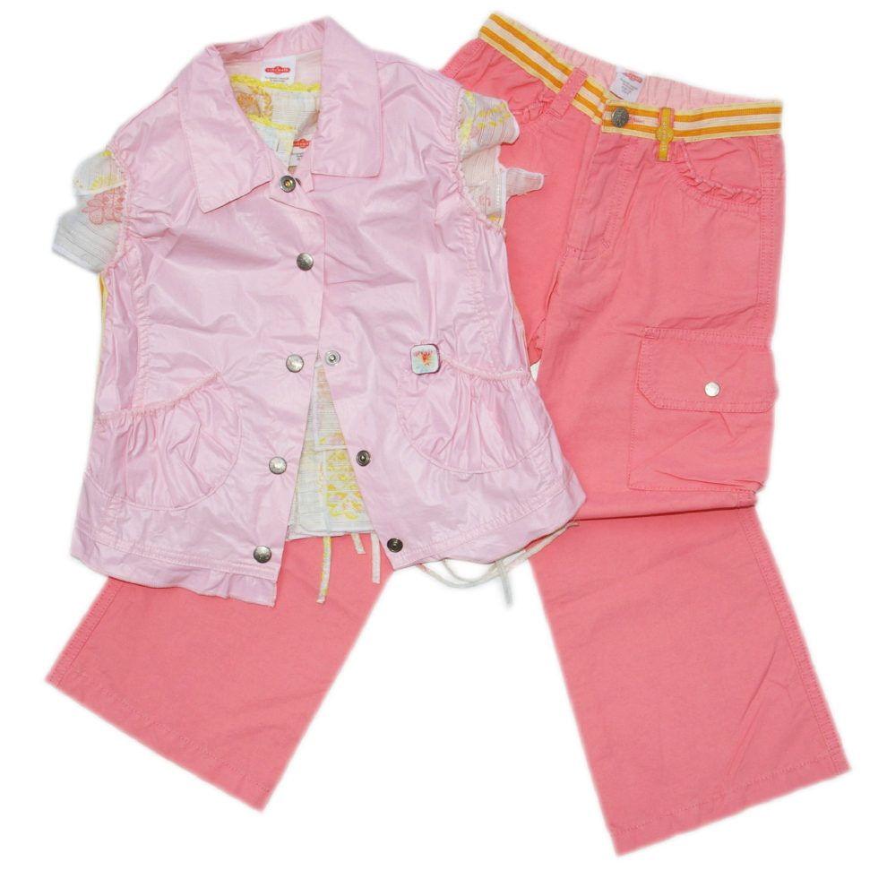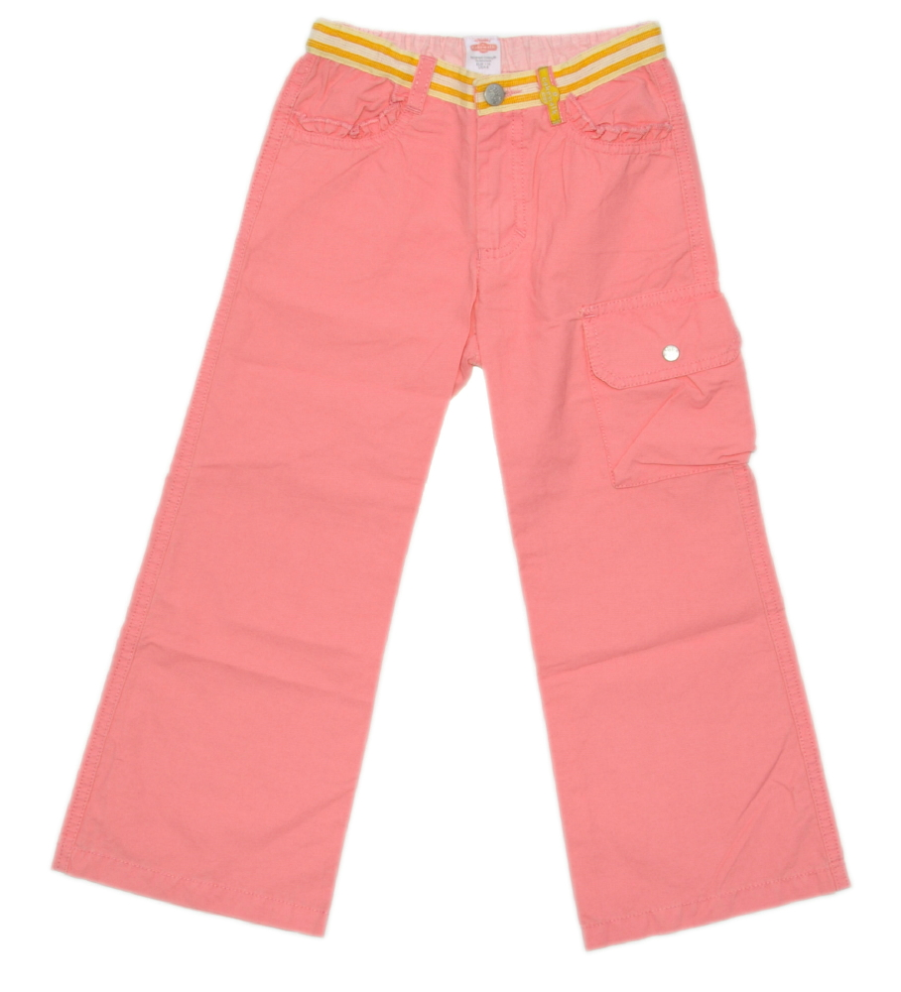

Cakewalk – Boys Tee & Long Shorts:
T-Shirt: Logo Print Tee RRP $80.00 $35.00
Shorts: Cropped Logo Long Jean Shorts RRP $180.00 $85.00

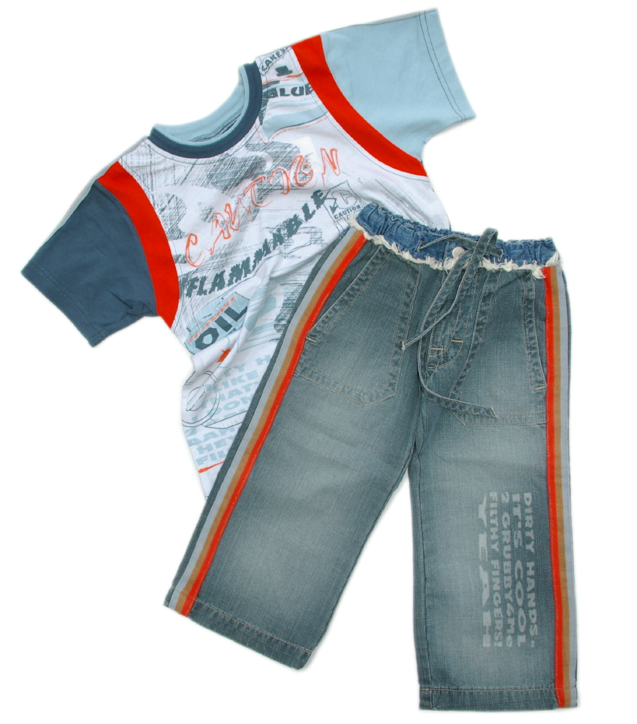

Cakewalk – Girls Stunning Pink Floral Detail Shirt RRP $120.00 $58.00

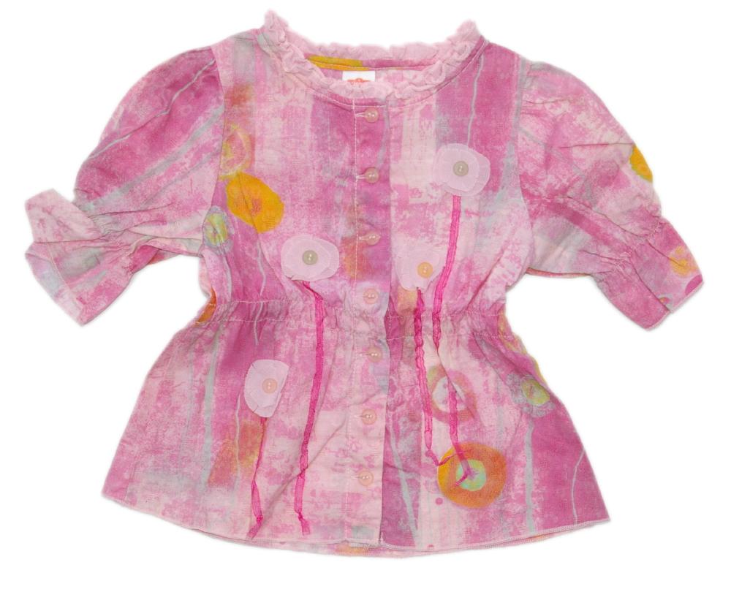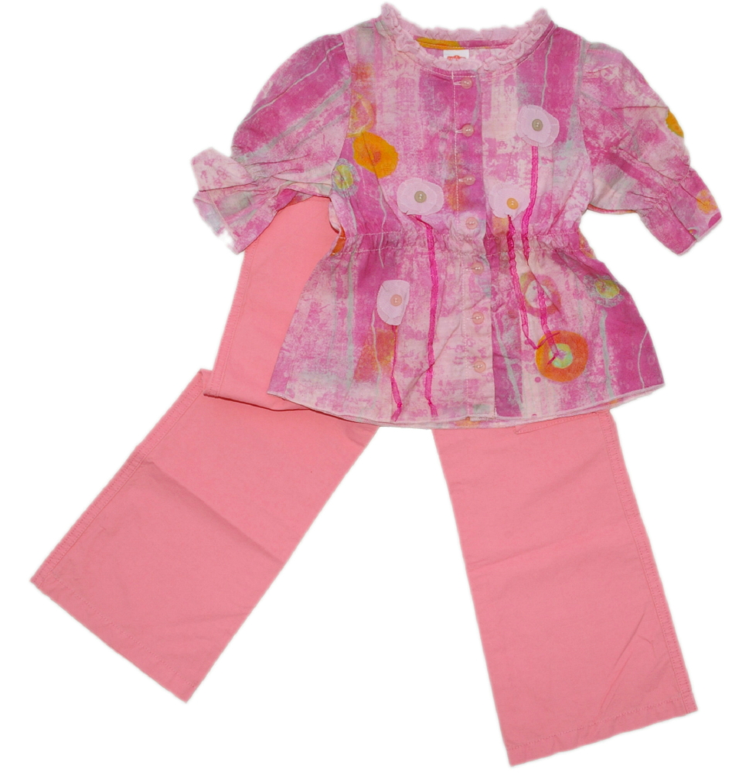

Confetti – Boys Summer Shirt & Shorts
Shirt: Cotton Check Dress Shirt RRP $98.00 $46.00
Shorts: Cotton Rust Long Shorts RRP $110.00 $55.00

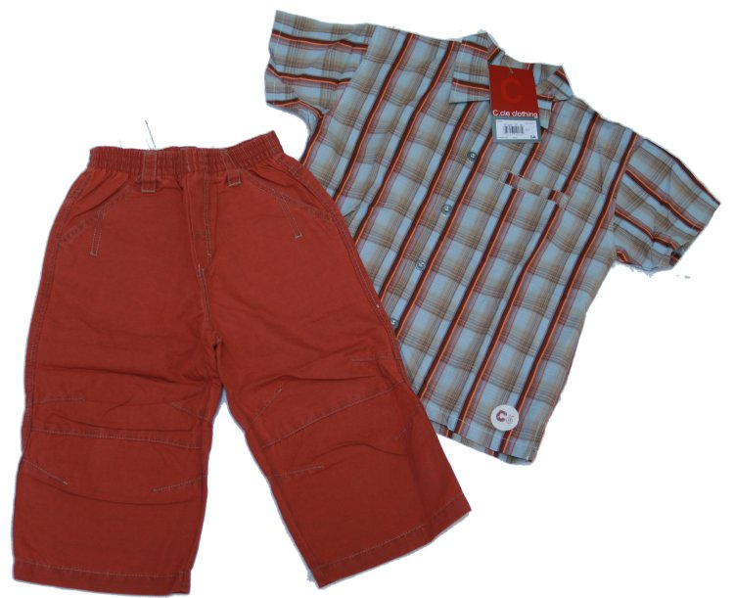

Bridget B – Girls Vintage Floral Print Dress RRP $77.95 $35.00
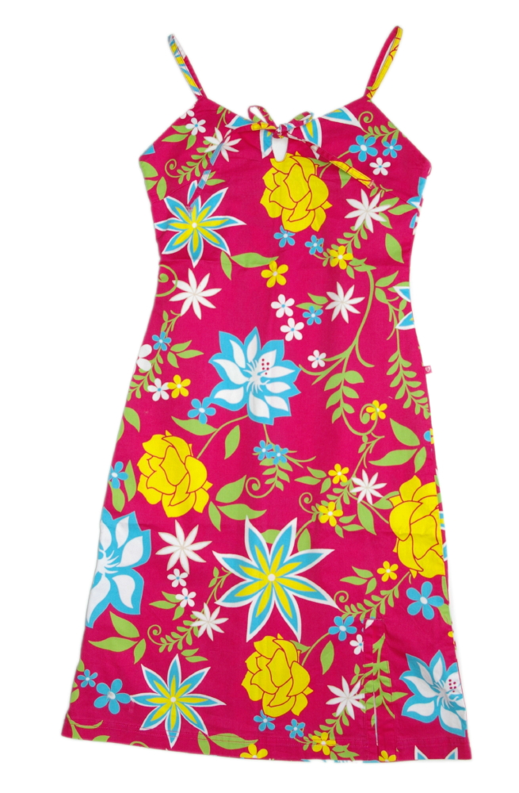

Mini Minors – Boys Shorts & Tee Set:
T-Shirt: Cobalt & White Stripe Logo Tee RRP $33.00 $15.00
Shorts: White Shorts with Cobalt Accents RRP $50.00 $30.00

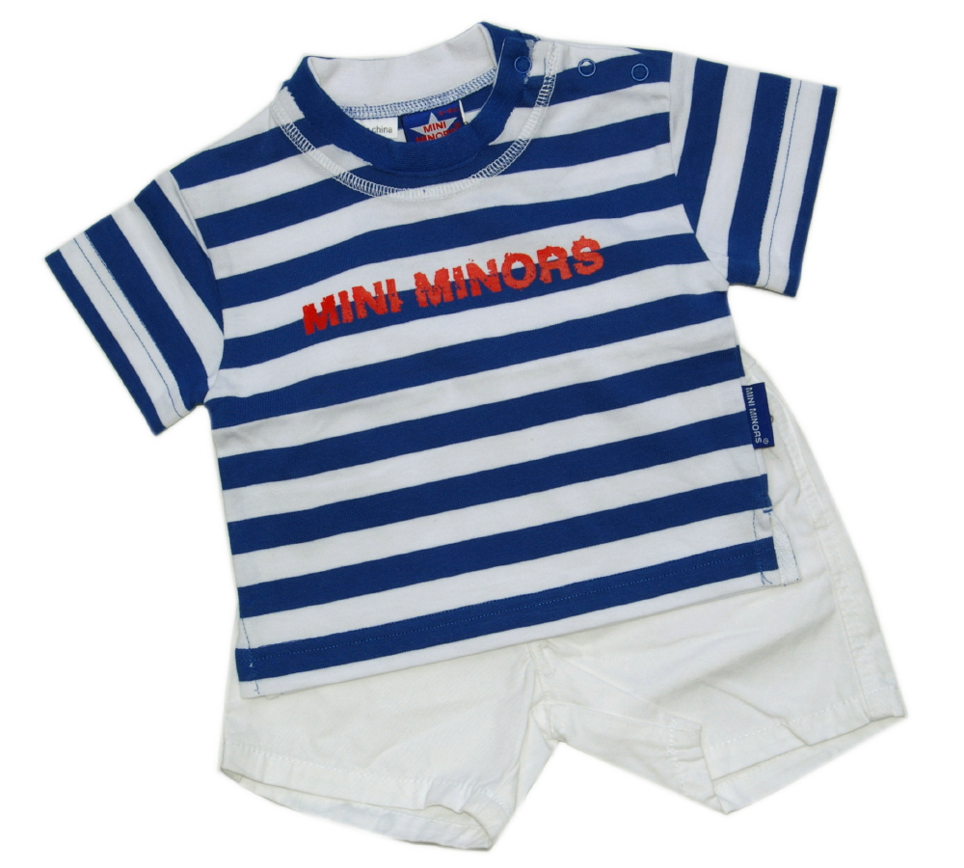

IKKS – Girls 2 Piece Summer Set:
Shirt: White T-Shirt with Floral Stamp Logo Print RRP $82.00 $40.00
Pants: White Cotton Pants with Floral Stamp Logo Print RRP $168.00 $80.00

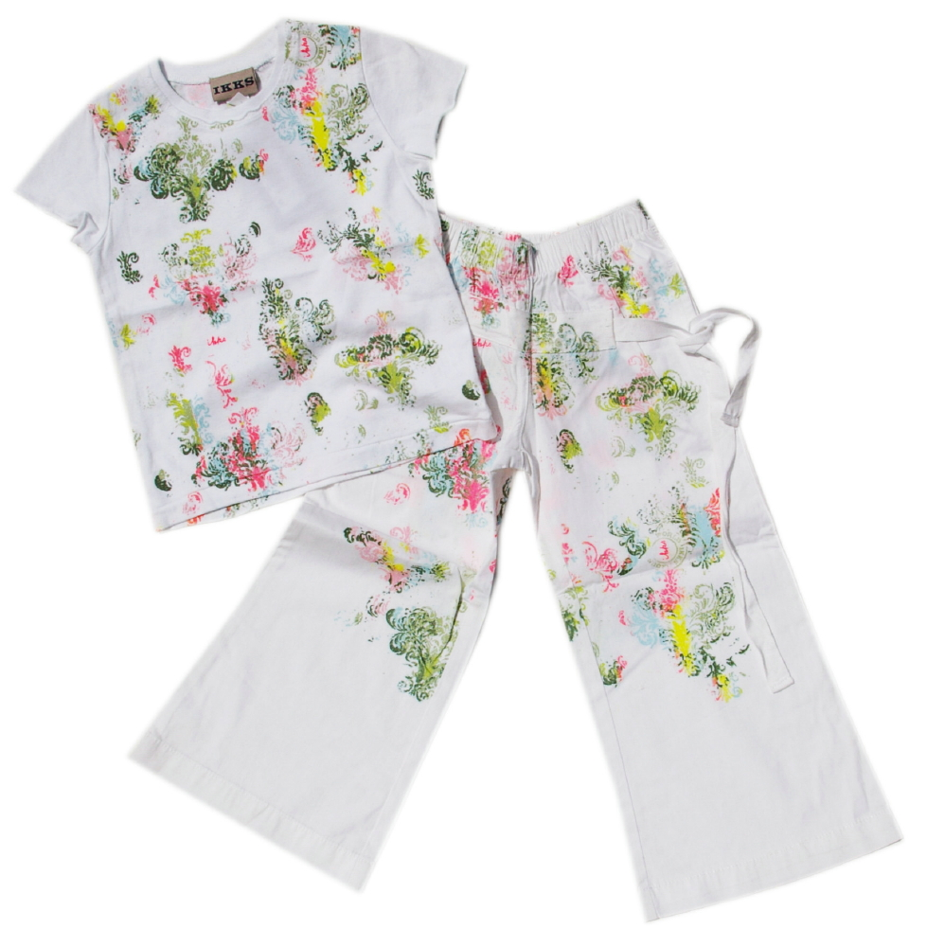

IKKS – Girls Singlet & Mini Skirt:
Singlet: Khaki Ribbed Logo Singlet RRP $74.00 $35.00
Skirt: Coral Pink Detailed Logo Mini Skirt RRP $108.00 $55.00

