PERTH ACCESS SCAFFOLDING PTY LTD
Aluminium Scaffolding

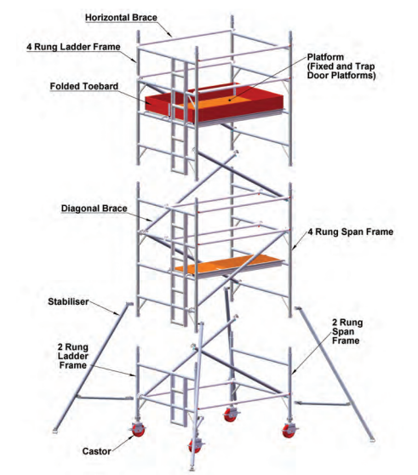
Aluminium scaffold hire services had emerged to be the best choice and alternative to ensure complete safety of the workers as well as money saving terminology. Sometimes many unusual expenses which is hard money earning of the business is been wasted. Smarter decision and thinking by buying scaffolds is substituted by acquiring the same on hire. The same can be avoided if a smarter decision is made and buying scaffolds is substituted by acquiring the same on hire. Aluminum scaffolds have gained a reliable name specifically in the construction industry due to their excellent tensile strength and rigid construction.

Scaffolding Mobile Tower
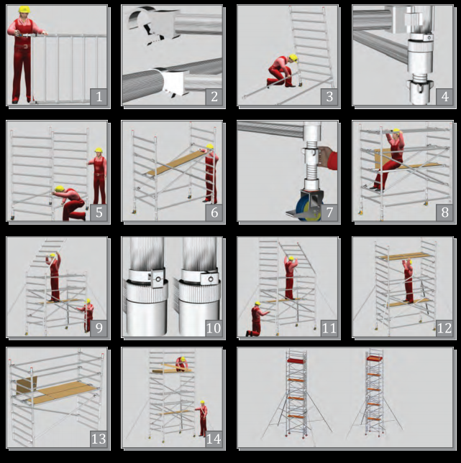
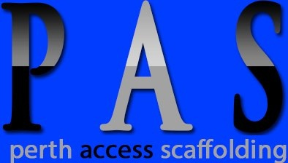
HEAD OFFICE:
PERTH ACCESS SCAFFOLDING PTY LTD
Office: 1/100 Beatrice st, Doubleview
WA 6018, Australia
Tel : +04 1554 8984
+04 4868 0130
Email : admin@perthaccessscaffolding.com
web : www.perthaccessscaffolding.com

