History of Meditation:

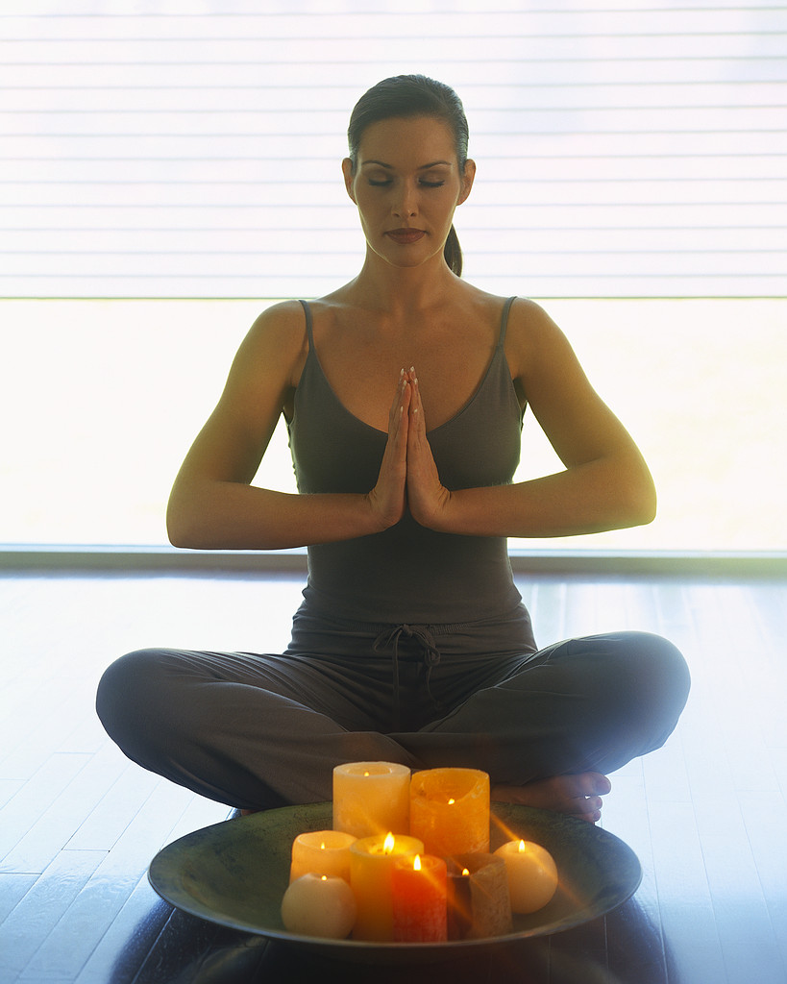

Meditation has its origins in ancient times, and has been around in recorded history for thousands of years. They found the proof of meditation, through Indian artefacts that were more than 5000 years old. Researchers found that these societies of hunters and gatherers as they looked after their flocks of animals, would have been in different states of consciousness at night, when they would gaze into the flames of their fires. Since then meditation has evolved and become more structured.

The biggest proponent for meditation was The Buddha, who represents the biggest icon for meditation since 500BC. And so the teachings of Buddha became popular in Asia. Then it spread slowly through other cultures and countries that then created their own special way of practicing meditation. When it hit the East it then took thousands of years to spread to the West. Then by the middle of the 20th century, it finally made its way to the west and gained popularity. Many researchers and professors of the 60’s and 70’s started to test the benefits of meditation, and how it helped with numerous things within the systems of our physical bodies.

THE BENEFITS: lowers stress levels, blood pressure, anxiety, depression, etc., it can balance mind, body and emotions. It can slow ones heart rate and breathing, because it takes one into a very deep restful state, which in turn is good for the body. People who meditate seem to have higher self esteem, and find they can make better choices, due to the fact that the mind is more focused and they can think more clearly.

All in all, meditation has many benefits, to the whole of you, mind, body, emotions, and self worth. You can practice meditation in your own homes, or in a group situation. Learning to still the mind though is not the easiest thing to do! It takes some time and devotion to ‘yourself’ with time out to practice it.

That time out might be 10 minutes a day. If you get up at 6am then put your alarm on to get up at 5.45am instead and put that small amount of time into practicing meditation. The simplest way to start is to find a piece of music, that is soothing, and play it in the background, then let your mind float, let it think of whatever it needs to. Then refocus it on the music, if it floats away again with thoughts like, “gosh I didn’t feed the cat”, or “that person that was awful to me”, let the mind think these things, without judging them, then refocus on the music. Do this simple technique everyday, around the same time with the same piece of music, without any expectations of yourself. Or just focus on your breathing and allow your consciousness to ‘sink’ into you so that your body relaxes and feels whatever you are sitting or lying on. It’s about disciplining the mind, and the whole Self.

Everyone’s needs are different and it’s important to find out the various ways to meditate so it can be effective.

Sourced and written by Erika Klement 0423593348. For more information call Erika on 0423593348.

