About Us
Kerry & Stephen OBrien are onsite operators who along with their son Beau are very excited to be offering this impressive facility to the mid north coast for you and your pets.

We have had past experience in pet boarding with Kerrys family having previously built and operated a large successful boarding kennel in Wagga. So whether it be your cat, dog, budgie or rabbit, we will always try to accommodate your pets.

We are here for your beloved friends and aim to cater for their individual diets and administer any medication as requested. We have an on call vet available if needed, or you may specify your own.

A light breakfast will begin the morning and to finish your pets busy day, a hearty dinner will be served before they settle in for the evening.

Your pets feeding habits will be discussed to ensure we know their favourites to help reduce separation anxiety from their owners. This along with a few special toys and plenty of attention will help make them feel at home.

Boarding Kennel Administration
To ensure minimal disruption and maximum attention to your pets, we have designated hours of trading for our kennels, unless by prior agreed arrangement.

Mon to Fri: 8am - 11am 3pm - 6pm
Saturday: 8am - 11am -----------
Sunday: ------------ 3pm - 6pm

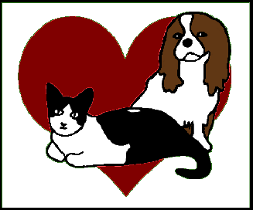
Vaccinations
A current vaccination certificate must be viewed, either prior to or on arrival. This can be faxed, emailed or presented in person.
The minimum requirement for a dog is the C5 vaccination and for a cat the F4. It is also requested and advisable for all pets to be treated with flea and tick control especially in the summer months.

