About Mary
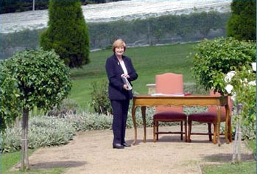 | I was born in England the third child in a family of four, both my parents were schoolteachers. At age 17 I left home to commence nursing training at Royal Devon & Exeter Hospital. During my final year I met my husband and on qualifying moved back to the Midlands to set up home while working as Staff Nurse on the Children's Ward at Kidderminster General Hospital.  We emigrated to Australia in 1970 with our two sons. We now have four grandchildren and are well established Australians.
Personal Background

Professional Background
A career in Nursing, Child Care and Public Service. An Accomplished Public Speaker and Trainer in Presentation Skills for the Corporate Sector and now Celebrancy - the most rewarding occupation of all!
Immediate Past President of the Association of Civil Celebrants of Victoria.

As Your Celebrant
Your wedding is important to me, it is unique, it is the only time the two of you will marry and make this lifetime commitment to one another. I am dedicated to working with you to design the wedding ceremony that is perfect for you. Whether your wedding is large or small, formal or informal it's yours to treasure for the rest of your life as husband and wife.
- Other Services
- Namegiving Ceremonies
- Renewal of Vows Ceremonies
- Theme Weddings
Address 10 Carolyn Court, Frankston, Victoria

