COLON IS OVERLOADED

One of the most important needs that the body has is cleansing. Our bodies constantly produce wastes or impurities which need to be removed from our system for us to remain healthy.

Colon is the major part of sewage system for solid waste and toxins from the body. Not only removes waste, but also helps the completion of digestive process and absorbing of important nutrients, minerals and vitamins.

Waste material, especially which has remained in the colon for some time creates several problems. (You can accumulate between 2kg to 20kg of waste between the colon walls!!)

These wastes are quite poisonous and they can re-enter and circulate in the blood stream making us feel ill, tired or weak.
It can also weaken the immune system, and cause digestive problems, headaches, depression, infection, tiredness, or to even more severe health problems.

They can also inhibit muscular action causing both or either constipation or diarrhea.
These problems lead to abnormal colon shape as the picture illustrates below.

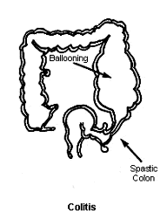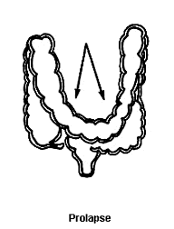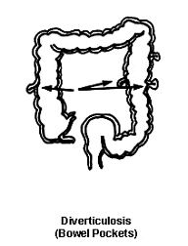

Symptoms of Overloaded Colon
Abdominal pain/Allergies/Headache
Bad breath/Bloating/ Fatigue
Food craving/Loss of appetite
Depression/Constipation/Diarrhea
Arthritis/Insomnia/Low back pain
Menstrual problem/Prostate/Nausea
Weight gain/Mental confusion
Poor concentration/Poor digestion
Bladder problem/Skin problem
Colon Hydrotherapy
is the quickest and most effective way of removing toxic matters from the bowel. It involves the gentle internal cleansing of the colon via the rectum. The water moves in and around the colon, it helps soften, loosen, rinse and hydrate the colon.

Brunelle Method of Colonic Irrigation has a unique feature. It utilizes a pulsating action in the colon, works as internal massage which enable the colon to reshape and strengthen. It works on the principal of a small amount of water being inserted into the rectum, stimulates the colon to defecate naturally, so no pressure is used.

The colon has reflex points to other parts of the body. With the Brunelle Method, the therapist can work on specific reflex organs to help the organ to perform better.
OUR CLIENTS

Our clinic values each client and treats them all individually.

One session takes approximately one hour. ($75)

People have different ideas about colon hydrotherapy.
Please feel free to contact us so that we can explain your queries with updated and realistic explanations. We are happy to speak to you personally.

*Please refrain from wearing perfumes and aftershaves or cologne.

*Please note colonics during the pregnancy, breast feeding and post-operation (6 months) are not recommended.

*There is no EFTPOS facility available. Apology for the inconvenience.
‘Health & Sickness Both Have Their Roots in the Colon’.
(Dr N. W. Walker)

“Death begins in the colon.” (V.E.Irons)

The colon is responsible for 92% of all physical ailments, sicknesses, and diseases.
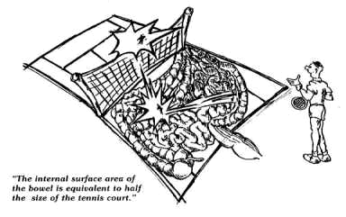

Rejuvenation Retreat
For IPL & Skin treatment
Cellulite Removing Machine
3352 3235 / 0420 870 906
www.rejuvenationretreat.com.au
Ancient Massage
Call Brendon 0410 655 699
Ai's Colon
Hydrotherapy
at Rejuvenation Retreat

Detox

For the better health

Colonic Irrigation

0402 39 77 18

07 3356 8057

Cnr of Days&Grange Rd Grange
Look for Federal Gov. building, next to Chinese Restaurant Ming Inn

colonic@digisurf.com.au

Trained in the Brunelle Method
Graduate of Australian Institute of Health
Association of ACHA

