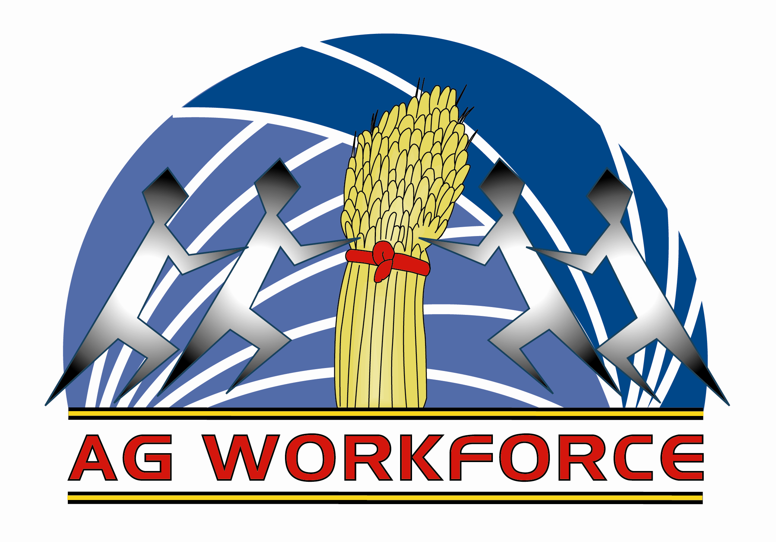
A little bit about AG Workforce
We specialise in farm machinery operator placements, especially in more skilled areas like row cropping and broad acre operations that use larger more technically sophisticated gear and GPS. We also have large piggery and feedlot clients to whom we supply casual and fulltime staff

As most employers are aware, it is difficult these days to find capable skilled people to fill general farm staff positions for long term placement. Our experience constantly demonstrates the financial benefits of hourly contract employment, rather than fulltime. More employers now understand the economies that can be achieved by using this method of employing not just labour, but competent safe staff, who are loyal, decent people who offer good value for money.

It is increasingly evident that the better wages we pay, the better type of person we get to work for us. We then seem to have fewer breakdowns and less accidents, but you don’t have to be Einstein to work out that one.
We have developed a ‘staff pool’ that we call ProAg Team. We can now offer our clients the convenience of getting qualified, competent staff, for spike activity work at short notice. Work like cultivation, planting and harvesting all fit this seasonally influenced category. The pool concept requires an attitude of co-operation that will ensure our clients of staff availability at all times. The ProAg Team comprises of people who have chosen a career in agriculture, driving specialised machinery. They are people who prefer work on the land, to working in the mines or construction industry.

We utilise the services of Ag Training, a registered training organisation that offers Nationally recognised certification in header and tractor operation. We believe training with a major emphasis on safety, is the way of the future. In fact, we foreshadow the time when OH&S legislation will make it essential for all staff to have a ticket to operate farm machinery, just as is the case in the mining and construction industry.

Before long, the availability of quality staff will become an influential factor, ultimately determining the viability of many farming operations. Last financial year the mining industry staff numbers grew by 49.7% with agriculture growing by only 1.3%. Recently coal hit a record $300/tonne. Our staffing problems are not going away, leastwise in the short term.
The stats say it all!!!!!

