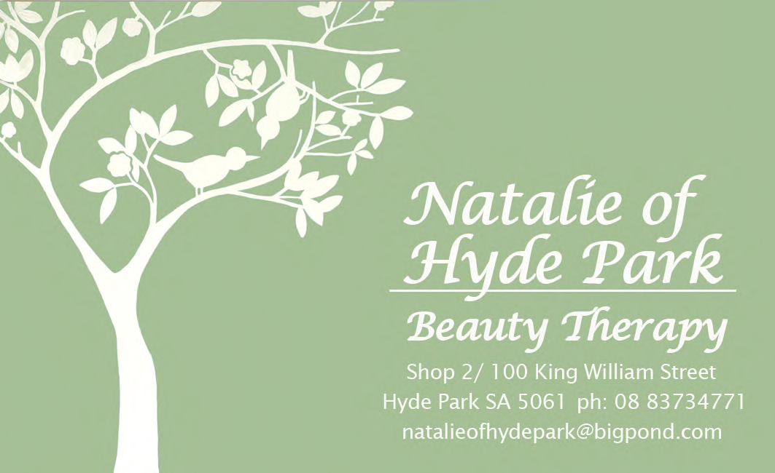
New MD Formulations Goddess Packs Available

Great Savings

Day Ritual-Total Age Protector and Moisture Defence Cream or Lotion $130

Night Ritual- Full Size Cleanser and Vitamin A Clearing complex $180

Plan Your Beauty Year and Save

Purchase a Series of 6 of Any Treatment and Receive

20% off

NEW Loyalty Program
Refer-a-Friend
Earn points referring a friend

If they come in with your referral and purchase a treatment or product you get the benefits

New Facial
Age Lift Facial

A firming Treatment Facial combines with Lymphatic massage to Lift, Firm Detoxify and Illuminate your skin.

Offered with a reflex foot massage, the natural way to relaxation and a feeling of well being.

For All Skin Types
Fantastic for Tired and Dehydrated Skin

April 2008
Newsletter

Dear Friends,
Well we are into the New Year and more than ready for a cooler Autumn. Many exciting things have been happening in the Salon. Jasmine is now 4 months old and a regular visitor at the Salon, Thankyou for all your kind well wishes.

We have now completed the initial renovations using Feng Shui principals advised by renowned Lucy Deslands has incorporated her attractive and meaningful artwork into our calming, elegant and clean décor to improve the energy flow within the Salon for the benefit of our patrons. As part of this reinvigoration of the Salon, we have adopted a new logo “The Love Birds” which hangs proudly on the main wall in the Salon.

We also believe that reinvigorating the Salon means adopting a philosophy of encompassing the needs of our patrons, so we are now open later on 3 days a week - Monday, Tuesday and Thursday.

As part of this philosophy we have also re-designed the Salon to include a comfortable Pedicure room so that you can now enjoy one of our fantastic pedicures with a friend, while relaxing and chatting. We have also developed a new menu that balances new and highly effective treatments with our Salon favourites that will firm, refine, rejuvenate and refresh your complexion and outlook on life. I have enclosed a copy in this Menu so that you can peruse our new services and products. This enhanced skin care environment is complimented by the Salon’s professionally trained and welcoming Skin Therapists who are committed to your optimal care during the year ahead. To ensure the highest of standards of skin care and treatments are offered Amber, Bethany, Kirsty, Gemma and myself have received exclusive, internationally-based skin-therapy, massage and make-up instruction and training that will mean the treatments you receive will be something special.

We look forward to see you in the salon over the coming months.

Regards
Rebecca Humphrys

Exciting

Newly Released To Australia
Belli Skin Care

Exciting New Menu
As a new mum I am Passionate about recommending our brand new Range of Treatments using Belli Skin Care, the only products specifically tested by doctors as safe for Pregnant and Breast Feeding mums and your precious little guys and gals.

We are the first salon in SA offering Belli Skincare Products and Treatments.

This range of product’s and treatment’s has been designed with safety and efficacy uppermost in mind and as such is the only treatments that I will wholeheartedly recommend for pregnant clients who are experiencing a changing body, unique skin care issues and balancing that against wanting to feel pampered and taken care of, while also looking after their baby (inside and out).

Belli skin care specifically excludes ingredients linked to birth defects during pregnancy and those ingredients so often present in a majority of skin-care treatments to ensure growing babies in-utero and nursing babies receive only the healthiest breast milk, or nurturing delicate baby treatments.

Belli is the only skin care company in the world that performs critical Teratogencitiy screening of their ingredients via MEDLINE, TOXLINE and TERIS teratology databases. Many skin-care products offered today contain compounds that may negatively affect un-born and new-born babies. We would love to discuss the benefits of this range with all of our clients who are planning getting pregnant, have pregnant daughters/daughter-in-laws, pregnant wives or who have friends who are pregnant – WHY not bring them in or recommend them.

Even if you’re not pregnant this range is incredibly gentle and may be the answer to highly sensitive skins that are not ideally suited to our other leading ranges of treatments or products.

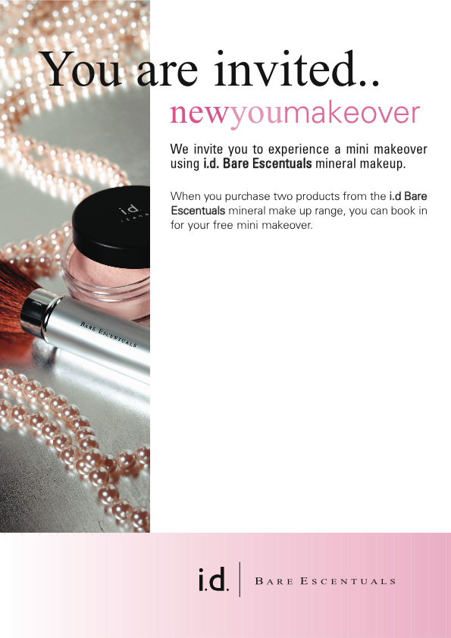
WHY i.d Bare Escentuals

SO PURE YOU CAN SLEEP IN IT

The Bare Escentuals makeup line is professional quality, multi-functional makeup for the not-so-serious makeup diva in everyone

It’s ‘foundation, cheek and eye colours are free of preservatives, oil, fragrance, binders, talc and other chemicals that may irritate the skin.

Because it is derived 100% crushed minerals, bareMinerals products are loose, silken, natural earth colour powders.

This revolutionary formula works to perfect uneven skin tones, protect the skin, and add a natural radiance, enhancing individual beauty.

Bare Escentuals lipsticks, glosses and liners are made by combining these same minerals with pure shea butter, jojoba oil and therapeutic essential oils, resulting in rich long lasting colours that retain your skins natural hydration

It is ideal for dermatological, post-surgical patients, as well as women combating skin irritations who are generally sensitive to chemicals and traditional makeup brands.

md formulations + Bare Escentuals
= Complexion Perfection

We Invite You To a mini Make Over using i.d. Bare Escentuals Mineral Makeup

New range of Lip Sticks and Makeup Packs. Skin care makeup good for your skin

Our Professionally Trained Team can colour match the makeup suited to you. Show you technique of how to get the best results from your makeup
Come in and get a makeover $30 deposit redeemable on purchases.

Call - Book Today

Gift Voucher
$25 OFF ANY Specialised Facial
Present this Voucher at time of Treatment
Valid until April 30th
$25
$25

Product chat:
MD Formulations

Moisture Defense Antioxidant Lotion
With four powerful antioxidants to defend against environmental stress and natural plant extracts for soothing care, this serum restores vital moisture and rebuilds the skin's protective barrier. It also provides smooth, supple skin. With continued use, fine lines diminish and moisture levels surge.

VIT A PLUS
Younger-looking skin starts here! Our Vit-A-Plus Night Recovery will transform your skin, revealing the smooth, beautiful skin you were born with.
For smoother skin almost overnight, Vit-A-Plus Night Recovery rapidly improves skin texture and refines pores, while controlling blemishes. Our revolutionary solution diminishes the appearance of fine lines and wrinkles, and increases skin resiliency. The time-released formula works all night to reveal younger-looking skin every morning.

Priori Peel What is it?
Advanced Technology
Pro Treatment Peel

This hi-tech peel system is suitable for all skin types. The PRIORI Pro Treatment Peel is made up of AHA, BHA and Idebenone.
So what does this mean for you?
It means that you are receiving the ultimate synergy of ingredients developed into one amazingly active yet gentle peel! It also means that you will see a visible improvement in your skin texture and clarity whilst increasing skin hydration and firmness. Try it for yourself, you won't be disappointed.

The Superceutical Peel
A series of these facial treatments helps improve skin elasticity, fine lines, wrinkles, texture, tone and clarity. This treatment offers effective age management; encourages growth of healthy new skin cells, removes layers of dead skin, and increases skin moisture content. Face feels and looks fresh, glowing and hydrated. A great treatment for an instant skin boosting appearance! For all skin types, including sensitive; always the first step in any PRIORI Pro-Treatment skincare regime.

The Superceutical Anti-Aging Treatment
Ideal for mature, wrinkled skin and as a boosting treatment to the Superceutical Peel. An anti-aging treatment peel that provides dramatic and visible results specifically for individuals with advanced signs of aging. Brightens complexion, reduces the appearance of redness, lines, wrinkles, photo damage; dramatically improves skin texture, tone and clarity leaving the skin deeply hydrated. Recommended as a next-level treatment after a series of at least one Superceutical Peel.

The Superceutical Anti-Pigmentation Treatment
A superior brightening and anti-aging treatment peel that provides dramatic and visible results for skin exhibiting uneven skin tones, age, liver and sunspots, melasma and other skin conditions with irregular pigment distribution. Dramatically improves texture, tone and clarity of the skin while leaving the skin deeply hydrated. Recommended as a next level treatment after a series of at least one Superceutical Peel.
PRIORI Advanced AHA benefits:

Multi-layer Skin Renewal and Essential Moisturization
The latest AHA technological advances combined with LCA Complex to enhance product performance and results. The first step in the PRIORI skincare collection designed to restore basic skin health and fitness that is the foundation of any skincare regimen

• Multi-depth skin exfoliation
• Increases epidermal and dermal moisture levels
• Stimulates dermal proteins: collagen and elastin fibers
• Helps revitalize dry, mature and sun-damaged skin
• Ideal for problem prone skin and mature recurring acne
• Minimizes fine lines and wrinkles, deeply hydrates and re-texturizes

Priori’s Super Ceutical New Advanced AHA Range

***Monthly Specials****

April Special
Get a Full Body Exfoliation when you book in for a Microdermabration with Ultrasound. Soften and Rejuvenate your skin from head to toe. For only $140 (valued at $195)

New Colours i.d Natural Lip Sticks
About Lipsticks:
• A plant-based, aromatherapy lipstick that is highly pigmented with pure minerals to give your lips true colour, vitality, and attitude
• Recommended for everyone, Lipstick is the number one ‘must have” cosmetic item
Product Features Benefits Candelilla, Carnauba, Bees & Jojoba Waxes Naturally derived waxes that lend substance and smooth texture to lipstick Shea Butter Superb moisturising ingredient Castor Oil Firm, shiny oil derived from the castor bean, it helps to protect lips from the elements and is very soothing Jojoba Oil A plant oil most similar to the skin’s own sebum, making it an ideal moisturiser Vitamin E Excellent healing antioxidant
Tips for Use:
• Use a Lip Pencil in a neutral or complementary shade to define and enhance the lips before applying lipstick
• Available in a beautiful palette of neutral to vibrant colours and sheer, satin, matte or shimmer finishes
• Use Mineral Veil on the lips in between Lipstick layers to ensure longer wear. It also makes lipstick matte if used on the top layer only

Electrolysis Hair Removal

What causes unwanted hair growth?
Hair growth is the result of heredity and hormonal levels. Also, some drugs, temporary methods of hair removal, and some illnesses can stimulate hair growth. Usually, hair growth is desirable. But when the hair is the wrong part of your body—a woman's upper lip or chin, the hands or arms—you may be considering electrolysis.

What is Electrolysis?
Electrolysis is a way of removing individual hairs from the face or body. Today's medical electrolysis devices destroy the growth centre of the hair with chemical or heat energy. A very fine probe is inserted into the hair follicle at the surface of the skin. The hair is then removed harmlessly with tweezers. The electric tweezer method is permanent. The truth is, the Food and Drug Administration in the USA and the American Medical Association recognize only electrolysis as a permanent method of removing hair.

How many treatments will I need?
Since many factors influence hair growth, you will need to return for several visits. The total number of sessions needed to remove hair permanently from a particular area will vary from person to person. Most clients return once a week or every other week, as necessary. But the unwanted hair will be gone forever once the series of treatments have been completed. Each treatment lasts between 15 minutes and one hour.

We use the The Blend Technique:
This method has a dual action, it combines the thoroughness of the Galvanic current with the swift action of the High Frequency current. These combined qualities make this technique the best there is available to date, especially when treating very deep and coarse hairs that have proved difficult with only one current type alone. This technique has made it possible to treat every problem with success. Now more and more salons are using this technique

Priori Peel Starter Kits
Smooth lines and Even Tones
$90
come with a free Priori Peel Treatment valued at $90

Dry Dehydrated Skin Try Thalgo

ABSOLUTE HYDRATION with Sève Marine®
HYDRA-MOISTURE SOURCE FACIAL

For dehydrated, tight-feeling skin. A fresh and enveloping mask that infuses the active ingredients to replenish the skin, making it softer, smoother and suppler.

ABSOLUTE REHYDRATING PATCHES FACIAL

For extremely dehydrated & / or sun-damaged skin. A double mask treatment that deeply replenishes the skin so regains its radiance and softness. This is the ultimate hydrating treatment for diminishing fine lines and improving the skin’s resistance.

NEW Loyalty Points Program
Get something back for being a Valued Client
*Terms and Conditions:

*1 point reward for every $20.00 spent on any service from our Treatment and Products Price List or Monthly Specials
*20 points must be accumulated before redeeming your points
*Points earned are on price of service or product excluding GST
*Points are not transferable
*5 points will be added to your record for client referrals, as a thank you from us to you. The more you refer the more you earn
*25 points will be deducted as our cancellation policy if we do not get 24 hours cancellation notice
*All your points will be void if we have not seen you within 4 month period.
*Points Policy is subject to change without notice.

Point Redemption :
*1 point is equal to the value of $1.00
*20 points are redeemable on fully paid services valued at minimum $20 or over from our Treatment Price List only
*Points cannot be redeemed on Product purchase, Monthly Specials, Gift Certificates, Packages & Touch-Up services from Treatment Price List
*Points redeemed on services from our Treatment Price List are GST exclusive

ENERGISING VITALITY CREAM
Action: Keeping the skin perfectly hydrated, this cream softens and revitalizes. Its stimulating effect awakens the skin.

Usage: Morning
Apply to a perfectly cleansed face and neck, preferably as a complement to the Absolute Re-hydrating Serum. Finish with gentle pressure from the fingertips to stimulate the skin.

