TERMX REPLENISHMENT SYSTEM
Reticulation Termite Barriers can be used in:
Pre-Construction work: treating the area under concrete slabs
Post-Construction work: an external termite perimeter barrier

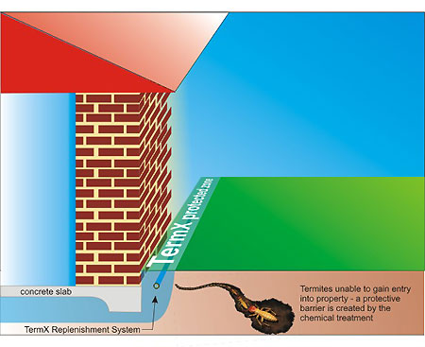
How TermX works
The TermX Replenishment System has been designed by Australian’s to suit the harsh Australian conditions and termite pressures. It has been extensively tested to offer long-term termite management and prevention.
The TermX Replenishment System is a specially designed pipe system used to apply termiticide chemical under pressure to saturate the soil medium surrounding a structure. This creates an impenetrable barrier (if repellent termiticides are used) or a death-trap for unsuspecting foraging termites (in the case of non-repellent termiticide chemicals) that move through impregnated soil.
TermX is a specially engineered system designed to deliver chemical termite treatments as a preventative measure for these pests. A certified TermX installer lays a series of replenishment system around or underneath a structure. At a later stage, chemical is pumped through the pipes to create a barrier of protection. Your certified TermX installer can make recommendations on how often the system needs to be charged with chemical – this is dependant on the type of chemical used and the termite pressure in your area. Once installed the system allows for quick application of a treatment to protect your most valued assets.

