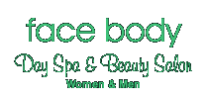

Founding Owner :Robyn Hamilton
A.A.B.TH. & International Therapy Examination council qualified.
Est.18 years in parramatta one of Parramattas' longest running beauty salons. (previously 124 marsden st parramatta, beside westfield.)

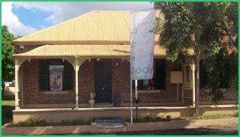

Welcome to our beautiful Mediterranean inspired Day Spa & Beauty salon, located in a heritage cottage on the outskirts of Parramatta, surrounded by leafy trees and parkland, a sanctuary for vital relaxation and rejuvenation along with our extensive range of beauty salon services.
We only have mature, qualified beauty professionals employed, no trainees.
Men as well as women, couples, friends wanting to spend time together are very welcome. Whether it be for a wax or you prefer to indulge in one of the wonderful day spa packages on offer and include a light lunch in our private courtyard, you will leave feeling like you've had a beautiful holiday and looking totally refreshed and rejuvenated.
We use and stock multi-award winning THALGO skincare which is at the forefront of international spa therapy and PURE FIJI whose Emmy Awards baskets given to the celebrities at the Emmy awards full of goodies such sugar rub, milk bath soak, exotic coconut oil, frangipani body butter (Nicole loved the frangipani) caused such a sensation.
PLENTY OF ON-SITE PARKING
OPEN LATE WEEKNIGHTS
GIFT VOUCHERS ARE AVAILABLE
visit our shopping cart:
http://faceandbod.cart.net.au
telephone (02) 96834338
Specialists in:
- Day spa packages
- Thalgo Day spa facials
- Thalgo beauty salon facials
- Detoxification
- Body exfoliation
- Body wraps
- hydrotherapy spa
- steam/infrared sauna
- Vichy shower
- waxing
- Fantasy Airbrush Tanning
- Youngblood mineral makeup
- Eyelash Extensions
- Manicare & Pedicare
Solarium

67 Victoria rd
Parramatta N.S.W. 2150
(between Betts st. & Macarthur st)
mon-fri 9.00am to 9.00pm
sat 9.00am to 6.00pm
Tel: (02) 96834338
Fax: (02) 96832533
Email: facebody@bigpond.com

