
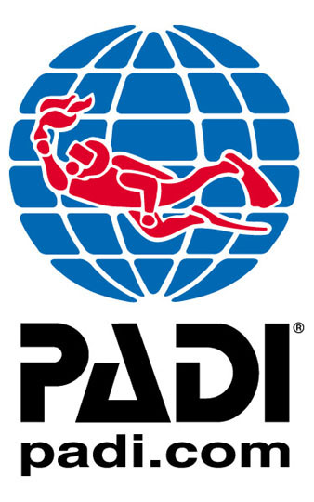

PADI Open Water Diver Course
Thank-you for interest in learning to scuba dive with Metro-Sports.

Few sporting activities offer the range and excitement of activities that diving can. As you are about to discover this is just the start of your diving career. Diving is one of the most varied activities human beings can engage in - from exploring wrecks or piers along our shores to interacting with aquatic wildlife in the tropical paradise of the Red Sea.

You will be taking your first steps into the underwater world joining the thousands of other new divers we have trained. The PADI Open Water course is designed to teach you competency underwater. You will possess the skills and knowledge to dive to a maximum depth of 18m anywhere in the world. You will be awarded the prestigious PADI Open Water certification. From here you can really start to experience the underwater world.

Diving In Victoria
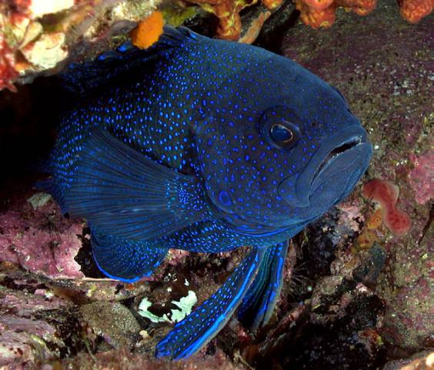
Victoria is home to some of the most unique diving in the world with an amazing array of marine life from Blue Devil Fish, Weedy Sea dragons, Big Belly Seahorses just to name a few. Victoria is also arguably Australia’s wreck diving capital and is home to hundreds of shipwrecks with over sixty of these discovered, identified and diveable and varying in depth from 8m to over 80m making wreck diving accessible to all levels of diver.

The crews at Metro-Sports are highly training PADI Professionals with a high knowledge Victorian dive sites and conditions and are qualified and insured to ensure that you are provided with the safest, most enjoyable and professional diving experiences.

Flexible Schedule
Metro-Sports are the only dive centre in Victoria to offer flexible course schedules to all clients. Unlike our competitors, we allow you to select the times and dates that suit you to complete each session. You can even book each session as you complete it's pre-requisite, which is ideal for people with busy and dynamic lifestyles that may find it hard to commit to modules in advance.
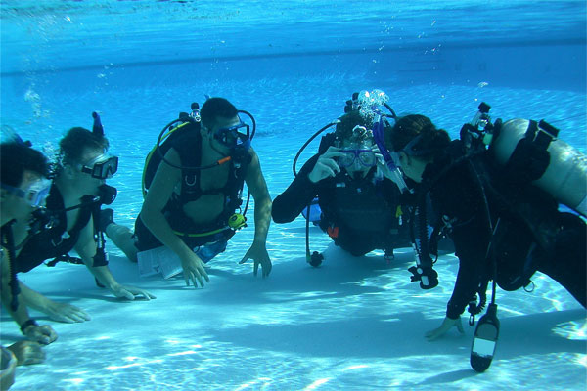
About the Course
During the PADI Open Water Diver course, your PADI Instructor takes you through the basics of learning how to scuba dive.

Your course fee is fully inclusive of all rental equipment (except for mask & snorkel), air fills, manuals, and classroom, pool and boat charter fees for the duration of the course. The only additional cost is that to obtain your diving medical which is payable directly to the doctor during your visit.
Upon enrolment, you will be sent your introduction pack, which will include your PADI Open Water diver manual and logbook.

At your own pace, you can complete the knowledge development home study portion of the course by reading through the Open Water diver manual and completing the Knowledge Reviews at the end of each chapter. This helps to minimize the time spent in the classroom completing theory training.

Once you have completed your knowledge development home study you are ready to book in to complete your classroom session where you will spend approx half a day reviewing the theory you have learnt during your self study, brushing up on any areas that you may have had difficulty, answering any questions and completing a short theory exam all ready to head to the pool.

Time to Go Diving…
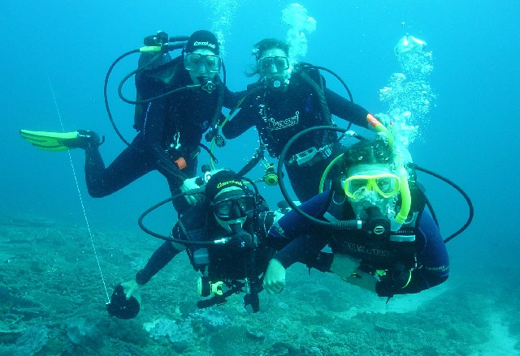
The next step in your PADI Open Water Diver course is to join your instructor for 5 modules of confined water (pool dive) sessions. This is an exciting day where you will learn how to assemble and check your equipment, learn and master the skills required to become a confident and safe diver and get used to the unique sensation of SCUBA diving. These pool sessions are typically run over a full day, but can be broken down by module if this is more suitable to your schedule and lifestyle.

Once you have successfully completed all of your confined water sessions, it’s time to go diving. You will complete a total of four open water dives in a combination of two shore dives and two boat dives. The dive sites and times will vary due to weather, tides, shipping etc and will be organized between you and your instructor at dates and times that are suitable.

Generally your open water dives are broken into two days; one day for your shore dives and one day for your boat dives; however these dives can be completed at different times if required.

Course Structure

Knowledge Development- Home Study
Theory/Classroom Session- 1 day in classroom with instructor
Confined Water/Pool Dives- 5 modules, generally over one day
(can be broken up if required)
Shore Dives- 2 Dives, generally on one day
(can be broken up if required)
Boat Dives- 2 Dives, normally over one day
(can be broken up if required, may vary depending on weather, shipping, tides and charter availability)

Course Price
Metro-Sports provide two options for payment of your course fees; we are the only dive operator in Melbourne to provide students with the option to pay as you go, we will only charge you for each module as you book it.

Alternatively, you may choose to pay your course fees up-front upon registration as an Open Water student; and you will receive a massive discount of $193.00.

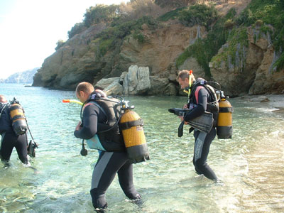
Below is a breakdown of the price of each module.

Registration & Booking $95.00
(This must be paid upon booking ALL Open Water courses)
Theory Session- $63 per session
Pool Session- $34.80 per module
Shore Dives- $160.00 per dive
Boat Dives- $120.00 per dive
PAY-AS-YOU GO PRICE $892.00 per person

PRE-PAYMENT PRICE $699.00 per person

Pre-Requisites

- Minimum age 15 years old
Suite 5, Level 2, 11 Hoddle Street | Collingwood 3066
E: adventures@metro-sports.com.au | W: www.metro-sports.com.au
PH: 1300 DIVING (1300 348 464) | FAX: (03) 8080 5949
- Valid Dive Medical Certificate
(Find your local dive doctor by visiting http://www.spums.org.au, alternatively call us on 1300 DIVING (1300 348 464) and we can advise you of your nearest dive doctor.)
- Two passport size photo’s

Further Information or Questions
If you have any questions about Learning to Dive with Metro-Sports, would like any more information either regarding the course or any of our other courses, services or products or would like to book your course; please call the team at Metro-Sports on 1300 DIVING (1300 348 464).

We look forward to seeing you in the water soon.

Kind Regards,

The Metro-Sports Dive Crew.

