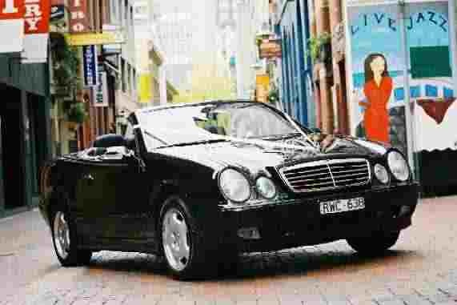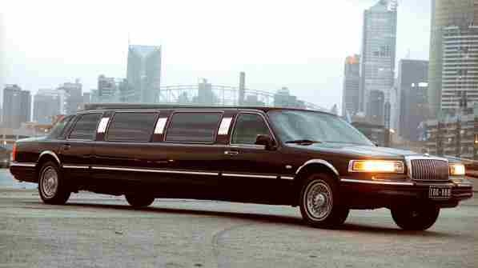
BLACK STAR LIMOUSINES
120 Reservoir Road
Yan Yean VIC 3755

Phone 0405 456 266
Fax (03) 9716 3511
blackstarlimousines@hotmail.com Price List 2008

Vehicles |  | 3 Hours | 4 Hours | 5 Hours | 6 hours | Overtime | After wedding Transfer (maximum 1 hour)
Mercedes CLK  Convertible | Up to 3 passengers | $490 | $540 | $610 | $660 | $75 per  ½ hour | $200
Mercedes E Class Sedan | Up to 4 passengers | $390 | $430 | $480 | $530 | $75 per  ½ hour | $200
Mercedes S Class Sedan | Up to 4 passengers | $480 | $540 | $600 | $640 | $75 per  ½ hour
Lincoln Royale  Limousine | 11 passengers | $690 | $790 | $890 | $990 | $75 per  ½ hour | $300  Extra $50 per pickup/drop off

Formal/Debs/social events Lincoln Royale Limousine $300 (1hr) One way $500 with Return trip
Free bottled water and mints for all wedding packages (Champagne included for Limousine Hire)
Winter special June to September receive 10% off our normal rates for sedans and convertibles.

Minimum deposit Sedans, Convertibles, Limousine $200 per vehicle
* All prices are inclusive of GST
* All Deposits are non refundable and transferable.
* Subject to terms and conditions copy available from our website

